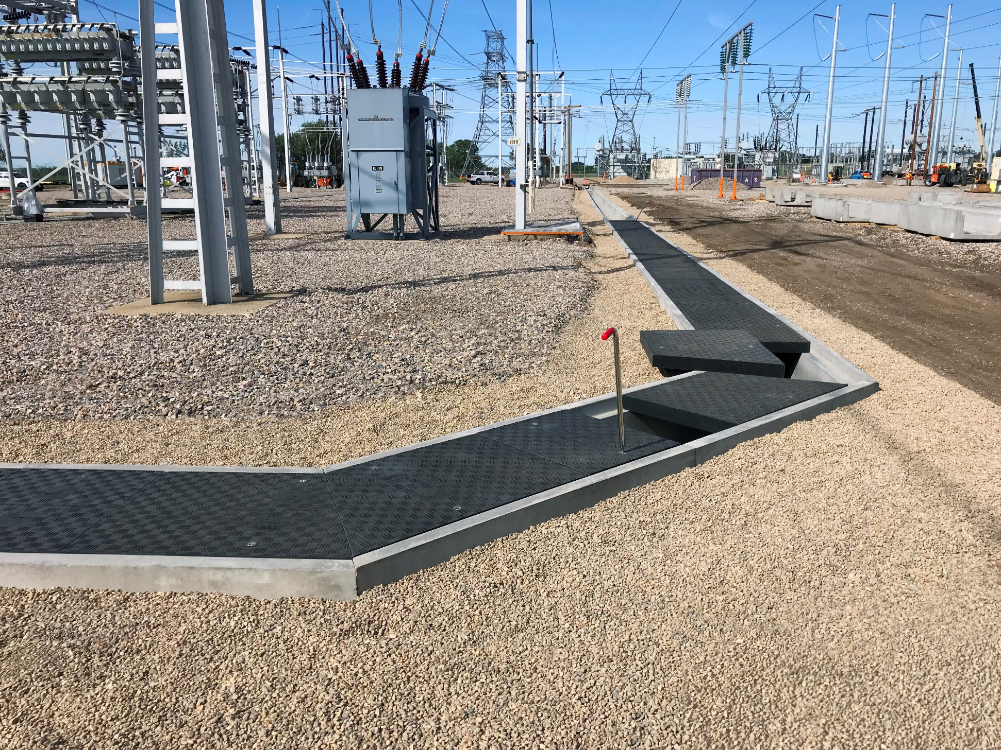
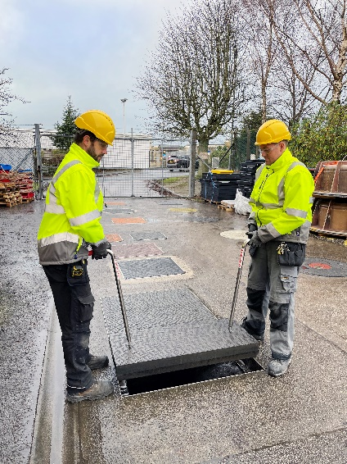
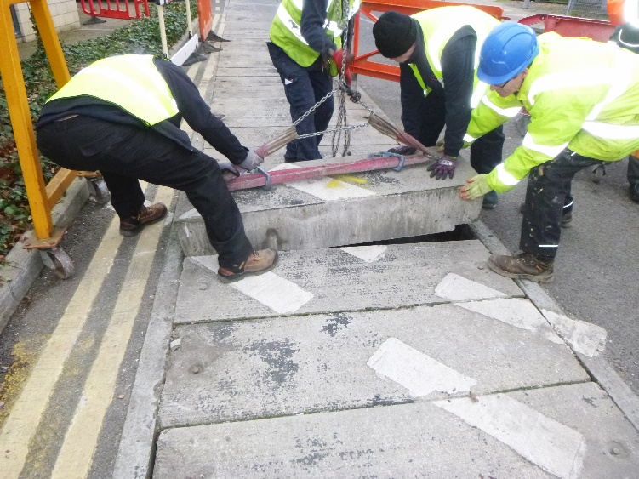
Strategic Partners: Precast & Preformed Troughs & Fibrelite’s ‘Made to Measure’ GRP Trough Covers
Concrete slab covers can weigh as much as five times the weight of an equivalent size Fibrelite GRP composite trough cover
Custom Fibrelite covers installed in precast concrete manufacturer Trenwa’s troughs at major US sub-station
Fibrelite trough covers are designed to be safely and easily removed by two people
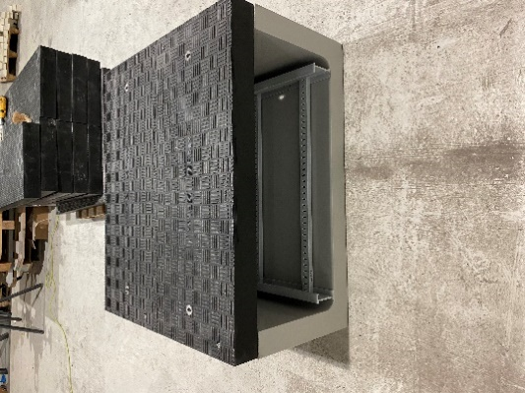
Composite access cover manufacturer Fibrelite has formed strategic partnerships with a number of major manufacturers of precast and preformed troughs (also known as trenches, channels and ducts) in Europe and the USA (including Fibex and Trenwa) to create new collaborative product offerings integrating Fibrelite covers and precast and preformed troughs, combining the strength and longevity of precast and preformed troughs with the easy, safe manual removal and durability of Fibrelite’s lightweight composite covers.
Custom Fibrelite covers designed & engineered to fit manufacturer Fibex’s preformed GRP troughs
Health and safety issues surrounding manual handling are of paramount importance to site managers. Without the necessary provision of dedicated lifting apparatus and training for operatives, traditional concrete and steel trough access covers can be a concern due to their sheer weight. Concrete slab covers can weigh as much as five times the weight of an equivalent size Fibrelite GRP composite trough cover. Fibrelite covers have an industry leading strength-to-weight ratio and are designed to be safely and easily removed by two people, using the Fibrelite FL7 ergonomically designed lifting handles.
Driven by focusses on health and safety, weight, durability (no corrosion) and reduced installation time, GRP composite access covers have moved from being a niche product used on petrol station forecourts to being specified at the outset of new build and retrofit projects for some of the world’s most prestigious brands in technology, data centres, ports, airports, high-tech manufacturing facilities, utilities, infrastructure and many more.
“In recent years, the demand for highly customisable, high-tech access covering solutions has grown exponentially, and we’re proud of the part we’ve played in their adoption over the 40 years since we invented the world’s first. Since then, we’ve continually innovated, focussing on creating solutions to industry and customer challenges.” Commented Jo Stott, Fibrelite’s Marketing Director “Partnering with precast and preformed trough/trench manufacturers was a logical next step, and I’m proud to say that, since we created our first partnership offering with Trenwa in 2014 we now have over 50 kilometres of our covers installed in precast and preformed troughs across the globe”
David Holmes, Fibrelite’s Technical Director added “We work closely with architects, contractors, and end users from tender stage right the way through to delivery and even installation where required. This collaborative process ensures that the supplied product fulfils both product quality demands and strict project completion deadlines. Fibrelite covers can be custom designed and manufactured with dimensions matched precisely to specified trough opening/rebate dimensions (Fibrelite’s adjustable tooling allows covers to be manufactured within millimetres of a clients requirement)”

Recent Installation: New Build Data Centre, Northern Europe
Some clients favour a complete GRP solution for both troughs and covers. Where appropriate, this can further reduce installation costs and time due to their reduced weight for transit and installation. Earlier this year, Fibrelite engineered and manufactured 550 metres of custom trough covers for a new build data centre in Northern Europe. These GRP preformed troughs were supplied with custom fit Fibrelite bolt-down covers, for added security.

Recent Installation: Cruise Ship Terminal, UK
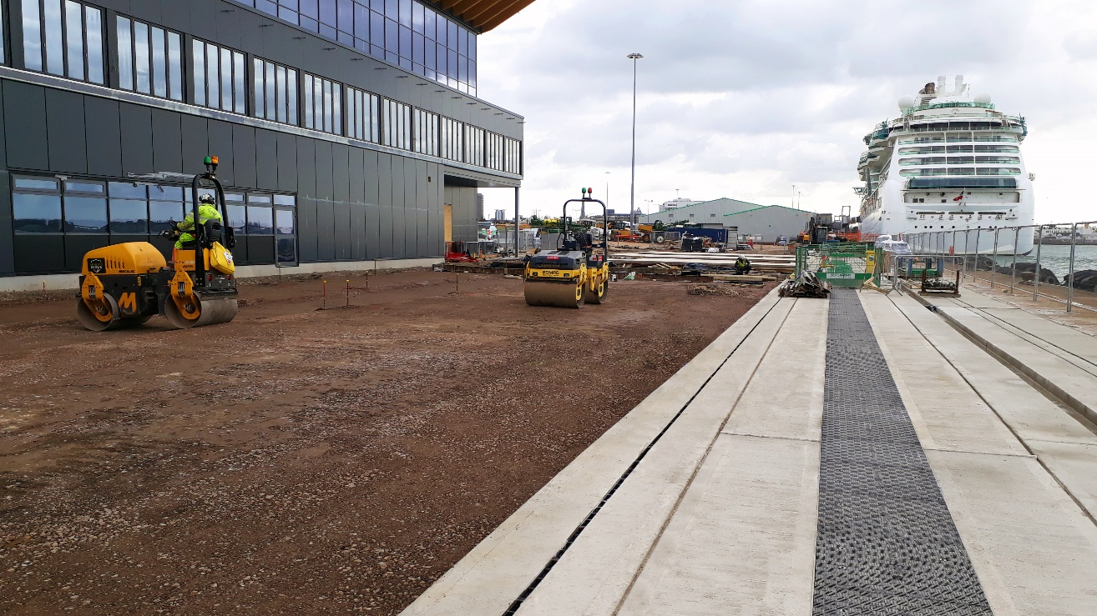
Fibrelite custom engineered and manufactured 500 metres of F900 (90-tonne) load rated GRP trough covers to fit precast concrete troughs at a UK cruise ship terminal. The stepped covers were supplied in a number of customised sizes to fit the trough configuration. The F900 load rated covers were stepped to reduce the unit weight in compliance with the customer’s specified manual handling limit.
F900 (90-tonne) load rated GRP Fibrelite trench covers in precast concrete troughs/trenches at
a cruise ship terminal

For more information visit the Fibrelite website: https://www.fibrelite.com/precast-concrete-trench-covers/

ENDS

Notes for Editor:
Full quality images available on OPW’s MyNewsDesk here
About Fibrelite
Fibrelite is a global manufacturer of highly engineered glass reinforced plastic (GRP) composite manhole and trough/trench access covers capable of taking up to 90-tonne loads while still being light enough to be removed manually using Fibrelite’s ergonomically designed lifting handles. The company is renowned for its high-quality technical support and service.
Initially developed 40 years ago, Fibrelite remains the composite cover of choice for projects the world over, from data centres and high-tech manufacturing facilities to infrastructure, transport and stadia, and is the industry standard for petrol station forecourts. Fibrelite covers are increasingly specified for both new build and retrofit projects across a variety of industries in more than 80 countries. To find out more, please visit www.fibrelite.com

